**Using the Solow model to study Climate Change**

**Deadlines:**

**-Round 1 (spreadsheet): 25 February, 08:30**

**-Round 2 (pdf report): 18 March, 08:30**

**Both rounds must be submitted via Canvas**

Use the student ANRs for naming the files. E.g., EGI_2022_A1_0123_32355_2322.pdf (.xlsx) is the first assignment, submitted by the students with ANRs 0123, 32355 and 2322.

Table. Student information

|  |  |  |  |  |
| --- | --- | --- | --- | --- |
|  | ANR | Email | First name | Family name |
| Student 1 | 2050053 | m.vandevel@tilburguniversity.edu | Mathieu | Van de Vel |
| Student 2 |  |  |  |  |
| Student 3 |  |  |  |  |

*Instructions*: The assignment consists of two rounds. In the first round you are asked to numerically simulate the extended Solow model in a spreadsheet. In the second round you are asked to submit a report with the interpretation of the numerical results. This second-round report consists of the questions marked with **[R2]** in this file, they should be answered here [as indicated below] and should be submitted as a .pdf.

The points for each question are provided in the rubric of Round 2 in Canvas.

The spreadsheet is not graded, but **the Round 1 submission is a pre-requisite for the Round 2 report. If you do not submit the spreadsheet with your calculations by the Round 1 deadline, your Round 2 Report will not be graded.**

The Solow model with technological progress is given by:

Aggregate output (1)

Productivity (2)

Population (3)

Consumption (4)

Physical capital accumulation (5)

Where:

investment rate

population growth rate

initial pop in 2020 (mill.)

initial physical capital stock in 2020 (mill. 2017 USD, PPP)

initial productivity index in 2020

Throughout this assignment we assume the following parameter values:

0.25 investment rate

0.03 population growth rate

0.33 elasticity of output to physical capital

0.04 depreciation rate of physical capital

g 0.02 rate of technological progress

and the following initial values

45.00

1075795.25

10862.74

You have access to a spreadsheet with the parameter and initial values presented above. These correspond to a hypothetical Upper Middle Income Country. It is your task to perform different simulations of the Solow model in the spreadsheet (Round 1). Based on these simulations you will analyze the economic implications of climate change and climate policy scenarios (Round 2).

*\*Note: For the simulation of the evolution of variables and the computations of their growth rates use the exponential formulation. For ‘a’ variable this is:*

*where is the growth rate of variable between year and year .*

* Use the information above to simulate the population up to 2100 (*column B*). Take as given the initial level .

Now we will perform a simulation exercise to obtain a baseline scenario without the effects of climate change and without the implementation of climate policy.

**Simulation 1 - Baseline scenario [*no climate change no climate policy*]**

* Levels (*columns E-G*): Simulate the GDP per capita (), aggregate capital (), and the productivity index () up to 2100. Take as given the initial capital stock , the initial productivity , (*column B*), and use equations (1), (2) and (5). (Present your answers with 3 decimals)
* Compute the year-to-year growth rate of GDP per capita that you obtain from this simulation (*column H*). (Present your answer with 3 decimals)

1. **[R2]** **Present a line chart of the growth rate of GDP per capita, computed in the previous step, as a function of time for the 2020-2100 period.**

Figure 1

1. **[R2]** **Based on the figure, is GDP per capita in 2020 below or above its steady state level. Justify your answer by explicitly referring to how the growth rate GDP per capita evolves over time. Approximately, in which year does the economy reach the steady state?**

From figure 1 we can see that the growth rate of y is decreasing over time, tending towards 0.02 as t goes to infinity. Theoretically, if an economy is below their steady state, then the rate of capital accumulation (savings) is higher than the rate of capital depreciation. Hence, as the economy is making more capital than it is depleting, it can grow and have a high growth rate of GDP per capita. As we inch closer to the steady state, the marginal returns of capital decrease, until the point where we deplete as much capital as we make, which is when our growth rate will be constant. The growth rate never truly reaches 0.02, which would be our long run growth rate as , however, it gets very close in 2100.

**Simulation 2 – Extreme weather events in the Solow model**

Every year different economies around the world are hit by extreme weather events. For instance, in 2021 the wildfire seasons in the American Northwest were particularly devastating and Europe was hit by unprecedented floods in the summer. These extreme events disrupt supply chains, require the re-allocation of government spending, and cause the displacement of workforce; all this ultimately hampers economic activity.

We incorporate extreme weather events in the model as negative productivity shocks. That is, we assume that when an extreme weather event occurs productivity decreases by a fraction .

In this case, the (*ex-post*) realization of the evolution of productivity is described by an adjusted version of (2):

, (2’)

where is an indicator variable, which is equal to 1 if an extreme event occurs in year . If there is no extreme event in year then is equal to 0.

Besides the (*ex-post*) realization of the productivity series, we can also describe its expected (*ex-ante*) evolution. This would characterize how we expect to evolve without knowing the precise timing of the extreme events, but with some information about the distribution of these events. For this, let us assume that the likelihood of an extreme weather event occurring in any given year is independent of the event occurrences in other years and follows from a Bernoulli distribution, with the probability of an extreme event occurring in year being *ex-ante* known and equal to : i.e., from the perspective of the initial year 2020 for any year , takes on the value of with probability, and with probability.

1. **[R2] Assume that productivity in year 2020 is unaffected by weather events and is given by . Show that, from the perspective of year (i.e., with the future realizations of being uncertain), the expected productivity in year is given by**

**, (2e)**

**where**

We can see the expected value of A at time t+1 as the probability of no event occurring times A without an event plus the probability of an event occurring times the value of A if an event occurs. This is based on the standard definition of expected values. We can write it as:

As an initial A(t) we can insert the expected A from the previous time period, so we have:

We can see that the expected value of is just the previous periods times a factor. If we start from , to find at time we multiply by this factor. To get at we multiply A(t=1) by the factor once more, i.e. we multiply twice with the same factor, just the probability being different. We can write it like that:

We can write:

Using this, we can express the expected level of output and the expected accumulation of capital as

(1e)

(5e)

Assume that in all periods, and that is equal to in all periods. The rest of parameter values are as in *simulation 1*.

* Use equation (2e) and the relevant parameter values, to simulate the expected productivity series up to 2100 (*column O*). Take as given the initial productivity level .
* Expected levels (*columns M-N*): Simulate the expected GDP per capita (), and the expected aggregate capital (), up to 2100. Take as given the initial capital stock , (*column B*), and use the expected productivity level computed in the previous step; use equations (1e) and (5e) and the relevant parameter values. (Present your answers with 3 decimals).
* Simulate a random realization of extreme weather events , i.e., a series of 1s and 0s, between 2021 and 2100 (*column Q*); assume .

Use the Excel function **IF(RAND()>=1-,1,0)** with as given above (*column P*). After generating the series of , copy and *paste only the values* (over the same *column Q*) such that a new series of random realizations is not produced every time you make changes to your file.

1. **[R2] List the years for which there is an extreme weather event according to your simulation.**

The years which had an extreme weather event were: 2036, 2057, 2079, and 2098.

* Use the random realization of extreme events computed in the previous step and equation (2’) to simulate the corresponding random realization of the productivity series up to 2100 (*column T*). Take as given the initial productivity level .
* Random realization levels (*columns R-S*): Use the random realization of productivity computed in the previous step to simulate the corresponding random realizations of GDP per capita () and aggregate capital (), up to 2100. Take as given the initial capital stock , (*column B*); use equations (1) and (5) and the relevant parameter values. (Present your answers with 3 decimals).

**Simulation 3 [effects of climate change]**

1. **[R2]** **Extreme weather events in this model are characterized by two parameters: and . Explain how these parameters are linked to the (expected) frequency of extreme weather events (i.e., how often we can expect them to occur) and their intensity (i.e., how destructive they are).**

is an element from 0 to 1. Let us look at the equation where is included: . is an indicator, which takes a value of one if an extreme weather event occurs. Hence, if takes a value close to one (because ) the term would be multiplied by a very small number (could be 0.01 perhaps). This would lead to a large part of the technology being destroyed and thus we can see the true strength of this parameter and how it is linked to the intensity/destruction of the weather events. The parameter represents the probability of such a weather event occurring, which was taken from a Bernoulli distribution with probability of 5% success. If we increase the probability of success, we expect to see an increase in the frequency of the weather events. Hence, the two parameters combined show a strong significance towards the frequency of extreme weather events and the intensity.

1. **[R2] Justify why an increase in can describe some of the potential effects of climate change. Cite scientific evidence (e.g., IPCC reports) to substantiate your answer.**

If we increase we are increasing the likelihood of one of these events occurring. According to a report on the ‘increasing probability of record-shattering climate extremes’ by Erich Fischer et al (2021) , the probability of extreme weather events occurring is increasing, and is already two to seven times more possible now, than in the past three decades. Furthermore, according to an IPCC special report (2018) “our planet is already 1°C warmer and we are witnessing extreme chaotic weather patterns”. Lastly, a more recent report from 2021 mentions not only the increasing intensity, but also that climate change is happening faster than predicted in previous models (IPCC, 2021). This would most likely imply that this frequency is also increasing, hence, increasing would allow us to represent these newer, increased probabilities of extreme weather events more accurately.

1. **[R2]** **Use equation (2e) and assume is constant, as it is assumed in *simulation 2*, to show that:[1]** 
   1. **The expected productivity growth rate is strictly decreasing in**
   2. **For a sufficiently high value of , productivity is expected to remain stagnant: for all .**

With being constant as we can write:

To find an expression for the expected productivity growth rate we need to derive expected productivity towards time:

The expected productivity growth rate is defined as:

We can derive the expression for the expected productivity growth rate towards to see how it reacts to changes in that term.

As the derivative is strictly decreasing.

Using our expression of the growth rate of we can also find an expression where it is stagnant, i.e. the growth rate is 0:

Plugging the value for into the expression for we find that it is constant as :

Assume now that and that every year it increases by until reaching in 2051; from then on remains constant and equal ; the rest of parameter values are as in *simulation 2*.

* Use equation (2e) and the relevant parameter values, to simulate the expected productivity series up to 2100 (*column Y*). Take as given the initial productivity level .
* Expected levels (*columns W-X*): Simulate the expected GDP per capita () and the expected aggregate capital (), up to 2100. Take as given the initial capital stock , (*column B*), and use the expected productivity level computed in the previous step; use equations (1e) and (5e) and the relevant parameter values. (Present your answers with 3 decimals).
* Use the new series of to simulate a new series of random realization of extreme weather events , i.e., a series of 1s and 0s, between 2021 and 2100 (*column AA*); assume .

Use the Excel function **IF(RAND()>=1-,1,0)** with evolving as described above (*column Z*). After generating the series of , copy and *paste only the values* (over the same *column AA*) such that a new series of random realizations is not produced every time you make changes to your file.

1. **[R2]** **List the years for which there is an extreme weather event according to your simulation.**

The years which had an extreme weather event were: 2036, 2047, 2057, 2061, 2071, 2072, 2078, 2079, 2084, 2087, 2091, 2096, and 2098.

* Use this new series of random realizations of and equation (2’) to simulate the corresponding random realization of the productivity series up to 2100 (*column AE*). Take as given the initial productivity level .
* Random Realization levels (*columns AB-AD*): Use the random realization of productivity computed in the previous step to simulate the corresponding random realizations of GDP per capita (), consumption per capita (), and aggregate capital (), up to 2100. Take as given the initial capital stock , (*column B*); use equations (1), (4) and (5) and the relevant parameter values. (Present your answers with 3 decimals).

Let us examine the expected economic implications of climate change through its effect on extreme weather events.

1. **[R2]** **Present a line chart depicting the following 5 variables as function of time, for the 2020-2100 period: GDP per capita under *simulation 1*; the expected GDP per capita computed under *simulations 2 and 3*; the random realizations of GDP per capita computed *under simulations 2 and 3*. Use a black line for *simulation 1*; dot-dashed lines for the expected GDP per capita; continuous lines for the random realizations; blue for *simulation 2* and red for *simulation 3*. Use a log scale.**

Figure 2

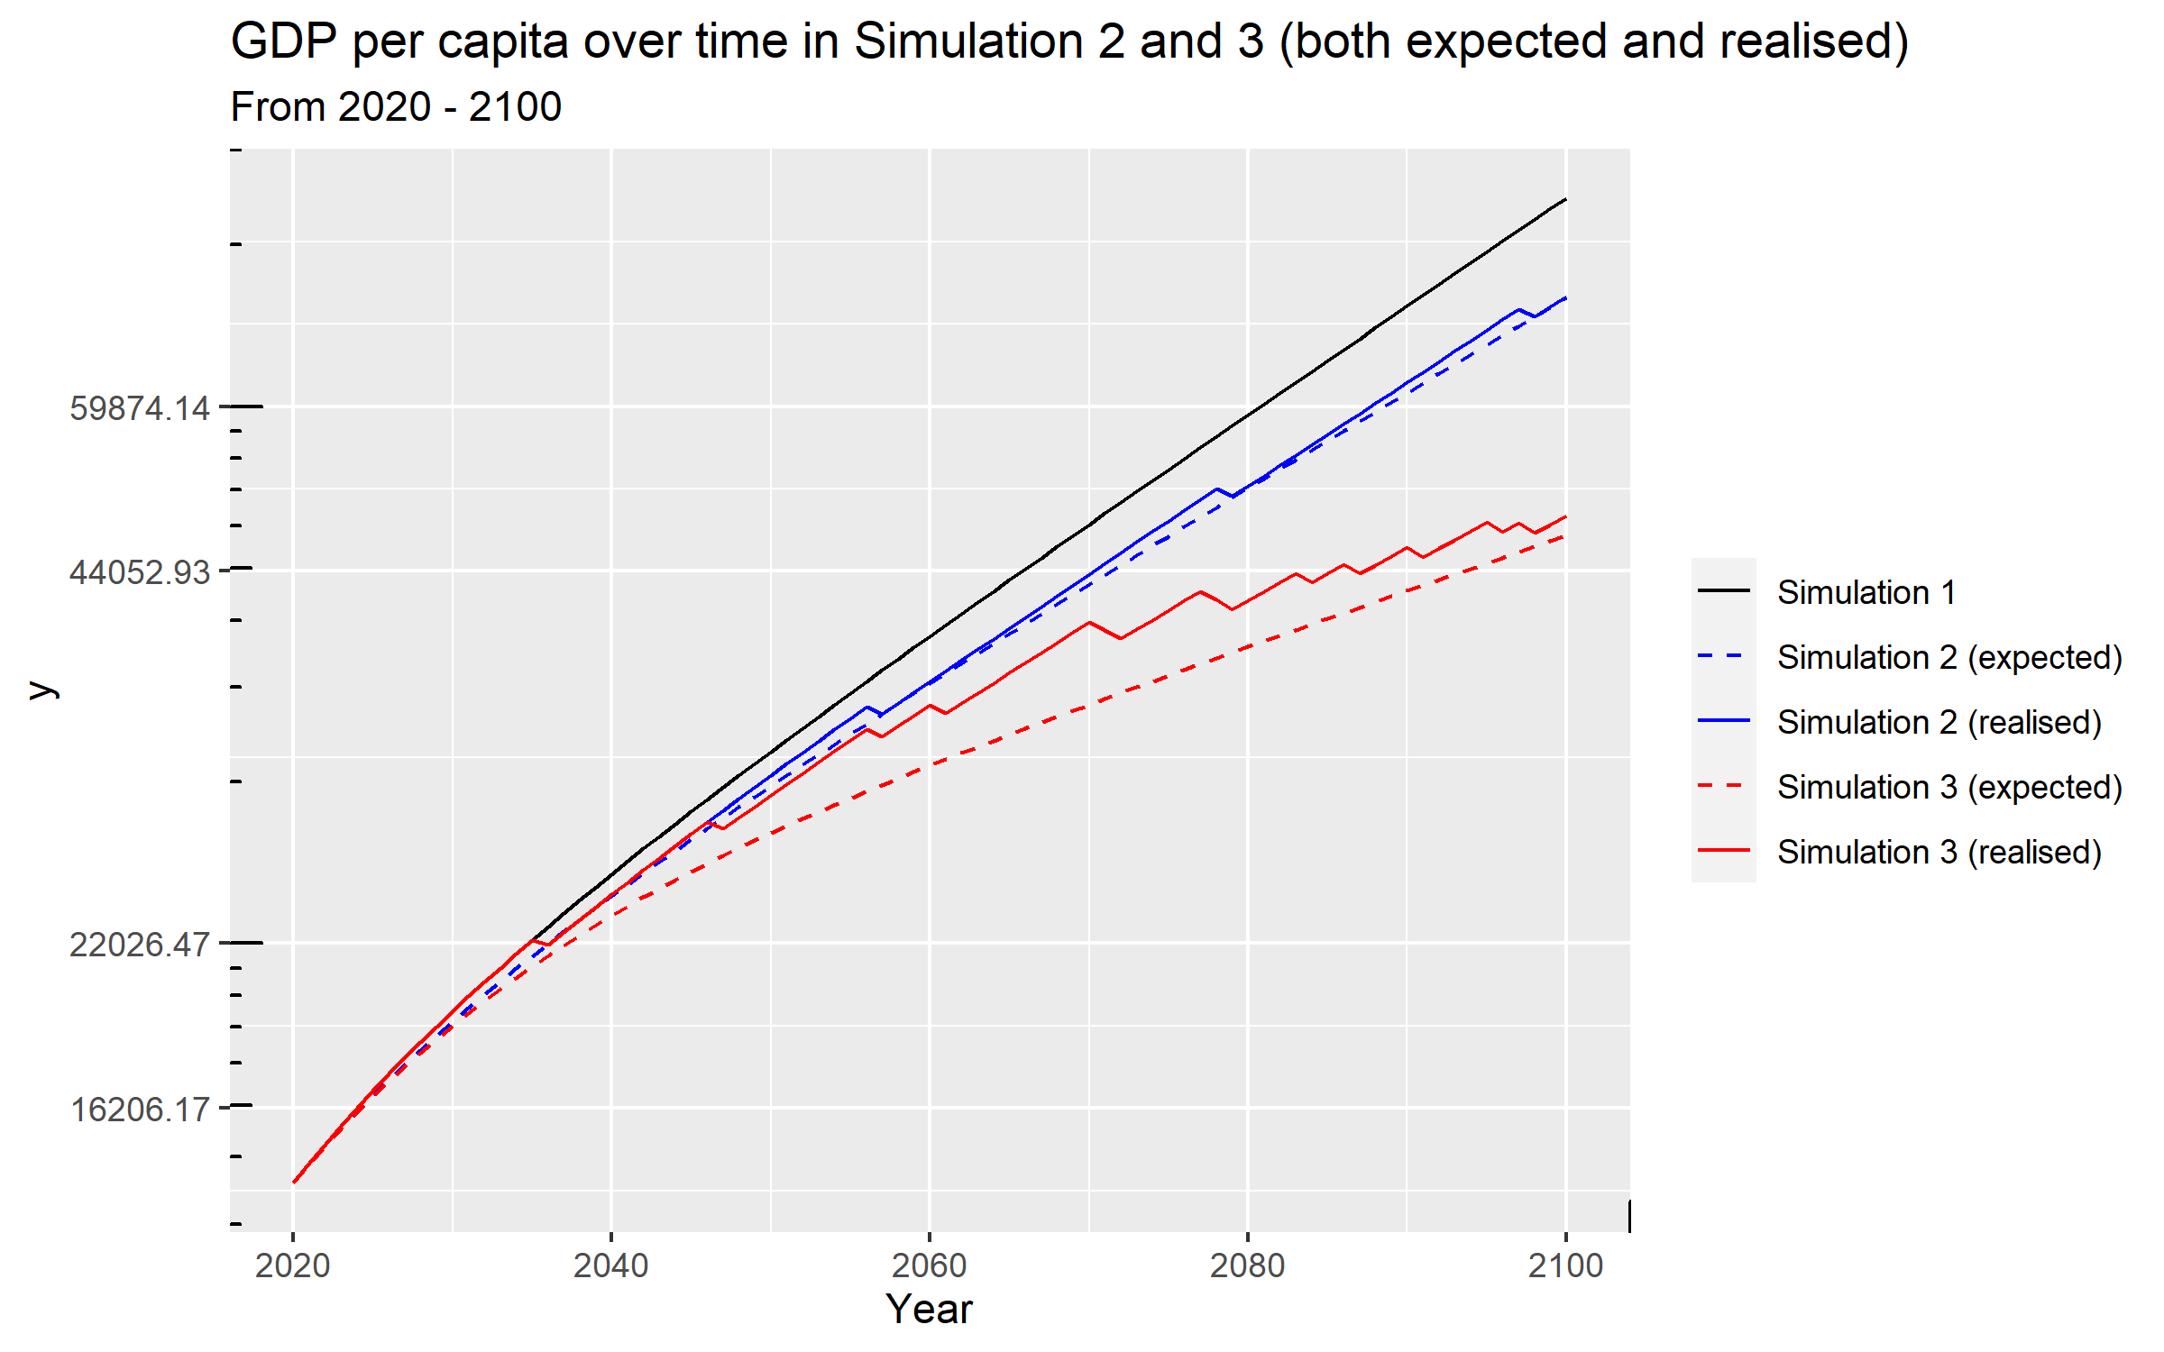

1. **[R2] According to what you observe in the figure, describe and explain the main differences when comparing the following**
   1. **GDP per capita in *simulation 1* Vs. expected GDP per capita in *simulations 2 and 3***
   2. **Expected GDP per capita in *simulation 2* Vs. random realization of GDP per capita in *simulation 2***
   3. **Random realization of GDP per capita in *simulation 2* Vs. random realization of GDP per capita in *simulation 3***

Part 1) In figure 2, as we move from simulations 1 to 2 and 3 we notice an increase in the level of GDP per capita overtime; and a decrease in the level of GDP per capita, comparatively , while maintaining a positive but smaller slope(positive slope 🡪 economic growth (positive )). Simulation 1

grows the fastest on average, while simulation 3 grows the slowest on average. In simulation 1, we do not have the variables and which reduce the growth of technology. In simulation 2, we do have this, however takes a constant value of 0.05. In simulation 3, grows, starting from 0.05 and increasing by 0.005 every round up to 0.2. This growing will thus reduce the growth rate of technology by a significant amount over time, resulting in a slower growth of GDP per capita, and thus the results in the figure seen.

Part 2) We see that the random realization tends to stick quite close to the expected value as time goes on. However, since this only happens occasionally, it does tend to deviate for a bit. This makes sense, as for the expected value, we take away a small piece of technological growth each period, while for the random realization we randomly, with the same odds, take away a larger piece of technology from the economy. Hence, as the random realization happens with same probability as the expectation is calculating for, it makes sense that the random realizations make these sudden jumps and reaches the same point as the expectation.

Part 3) We see that there are way more random realizations in simulation 3. As time goes on, the frequency of these random realizations also increases with simulation 3 (which makes sense, the simulation strives to mimic the growing issue of climate change and increases). This in turn causes the realized GDP per capita in simulation 3 to be much lower than in simulation 2.

We have established the negative impact of and on the expected growth rate of productivity. Combining this result with the climate science evidence that suggests that climate change can cause to increase, we can assess the long-run economic impact of climate change, through the ‘extreme weather events channel’.

1. **[R2]** **According to the results of the Solow model augmented with extreme weather events that we have developed up to this point in the assignment:**
2. **Is climate change expected to have a positive or a negative effect on the level of GDP per capita in the long-run? Use the elements of the model to justify your answer.**

As climate change is expected to increase the occurrence of extreme weather events (see question simulation 3, f), the model predicts that this would lead to a negative effect on the level of GDP per capita (in the long run too). In the long run we expect technology to fluctuate around the expected value of technology. From the expression we found in a previous exercises we can see that is lower the larger and are:  
As technology A is a part of the production function it codetermines GDP per capita. A lower technology level will cause a lower y.

1. **Is climate change expected to have a positive or a negative effect on the growth rate of GDP per capita in the long-run? Use the elements of the model to justify your answer.**

In this model the long run growth rate of y is fully determined by the growth in technology. As stated above, we expect the level of technology to fluctuate around the expected level of technology. Thus, we can see the growth rate of the expected level of technology as the “long-run” or “average” growth-rate of technology which determines the growth rate of y. In a previous question we derived an expression for the growth rate of the expected level of technology.

We can see that when climate change causes a higher or , we will have a lower growth rate of technology and hence a lower growth rate of y in the long-run.

1. **Compute the average annual (exponential) growth rate of GDP per capita () for the last decade of your simulations (2091-2100). Do this for GDP per capita under *simulation 1*, and for the expected GDP per capita under *simulations 2 and 3*. Complete the following table (Use 3 decimals).**

|  |  |  |  |
| --- | --- | --- | --- |
| Simulation | 1 | 2 | 3 |
|  | 0.020 | 0.018 | 0.010 |

**Simulation 4 [Climate policy: adaptation]**

The hypothetical economy of this assignment is small relative to the world economy and has little impact on global GHG emissions. Thus, its mitigation polices have virtually no effect on global warming and on the potential occurrence of extreme weather events. However, for this economy, the implementation of adaptation policies can play a significant role. More adaptive capacity (e.g., more resilient infrastructure, early warning systems) will result in less severe damages in case of extreme weather events.

Adaptive capacity, , can be modelled as a form of capital: economies can accumulate adaptive capacity over time through investment. As with physical capital, we assume that the investment rate in adaptive capacity is constant and given by and that adaptive capacity evolves according to

(7)

Adaptive capacity serves to prevent (some of) the negative effects of extreme weather events. Thus, the effect of extreme weather events is now endogenous (and no longer constant over time): when an extreme weather event hits the economy in period productivity decreases by a fraction , that is now takes the role of the parameter in the previous simulations. We assume that is a decreasing function of the adaptive capacity () relative to the size of what it is protecting (). Specifically

; . (8)

1. **[R2] Use equation (8) to show that:** 
   1. **is strictly decreasing in**

1. We take the derivative of with respect to . As it is strictly negative, it is strictly decreasing.

In this scenario, the (*ex-post*) realization of the evolution of productivity is described by an adjusted version of (2’) that accounts for the endogeneity of the effect of extreme events on productivity, :

(2’’)

In this version of the model we also need to account for the allocation of resources to adaptive capacity investments. As such, the fraction of output that is allocated to consumption is now given by , and equation (4) becomes

(4’’)

Assume , , , and ; The series of and the rest of parameter values are as in *simulation 3*.

* Random realization levels (*Columns AI-AN*): Use the same random realization of extreme events computed for *simulation 3* (*column AA*) and simulate the corresponding random realizations of GDP per capita (), consumption per capita (), aggregate physical capital (), adaptive capacity (), fraction of damages (), and productivity (), up to 2100. Take as given the initial capital stock , initial productivity , (*column B*); use equations (1), (2’’), (4’’) and (5) and the relevant parameter values. (Present your answers with 3 decimals).

1. **[R2]** **Compute the ratio between consumption per capita under *simulation 4* and consumption per capita under *simulation 3*, for each year between 2020 and 2100 (*column AP*). Present a line chart of this ratio as a function of time, for the 2020-2100 period.**

**Figure 3:**

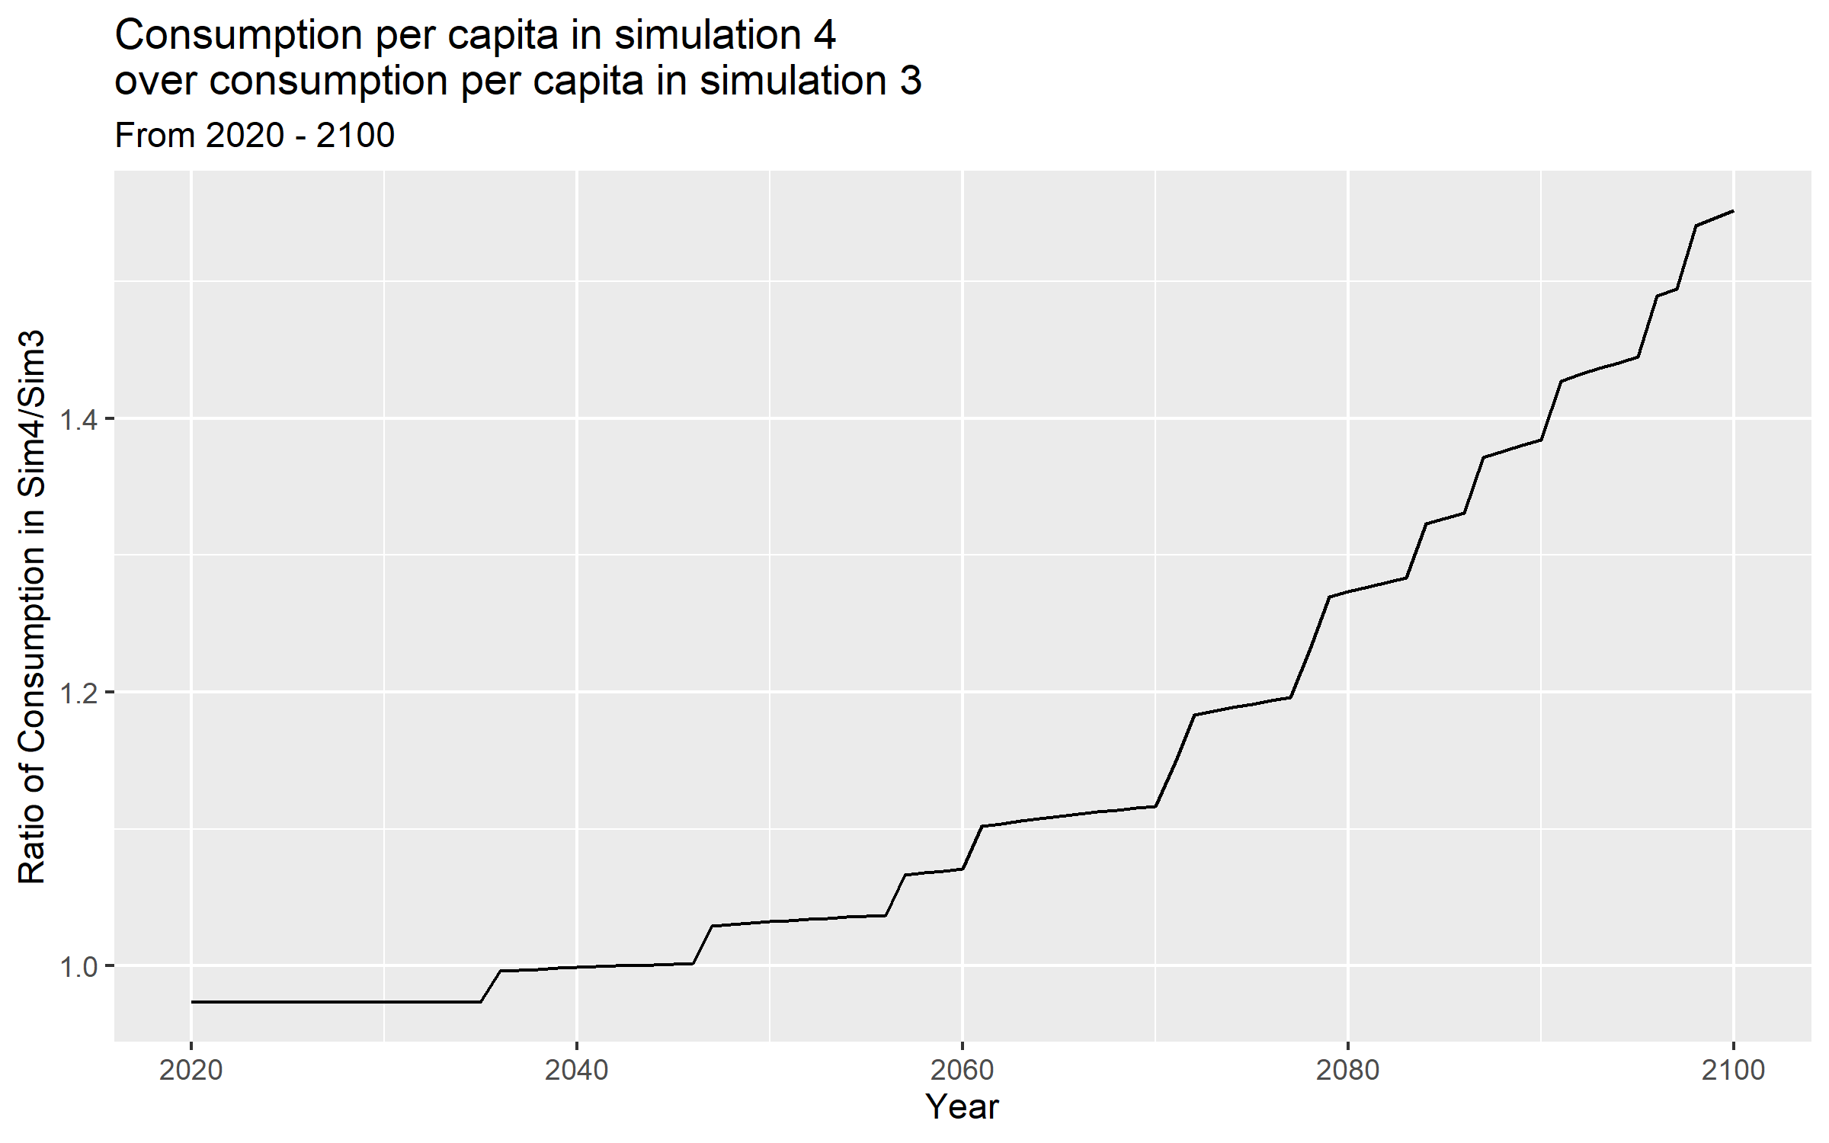

1. **[R2] Describe and explain what you observe in the figure. Explicitly refer to the intertemporal trade-off embedded in the implementation of climate adaptation policy: short-run costs and long-term benefits.**

The graph starts with the consumption per capita in simulation 4 being lower than in simulation 3. This is because the total savings rate is higher in simulation 4 as some of output is spent on adaptive capacity investment. However, this pays off when the first weather event occurs in 2036. Technology is reduced by less in simulation 4 than simulation 3, thus output decreases by less and as consumption is a fraction of output, also consumption decreases less. This happens similarly every time there is a weather event, signified by a “step” in the function. Furthermore, we can see how the “steps” gets higher and higher as more and more adaptive capacity adaptive capacity investment accumulates. Another point to note is that the flat parts of the graph, i.e. the time periods where no weather event occurs become steeper and steeper. Because in simulation 4 we have more technology even when there is no weather event occurring, technology increases more than in simulation 3 as A increases exponentially and its growth depends on the previous value of A.  
As we can see in the graph, until the first weather event occurs, consumption in simulation 4 will be lower as part of y is spent on adaptive technology. However, once weather events occur and simulation 4 is affected less we can see how it overtakes simulation 3. Additionally, in the beginning the probability of a shock occurring is quite low, so it is probably that it will take a long time until the additional investment pays off.

**Taking stock (critical assessment of the model)**

1. **[R2]** **What are the main merits of model that we developed in this assignment to study the economic implications of climate change and climate policy?**

The model displays nicely how negative shocks on production caused by climate change can decrease living standards in the long run. By calculating the expected value of capital per income we can also see how the standards of living of an economy with and without climate change will diverge further and further.   
Especially when including adaptive capacity investment one can see the intertemporal trade-off of investing into climate change mitigation. This can be used to explain the current inactive climate policy of many countries.

1. **[R2] What are the main limitations of model? Propose a direction in which you would extend/alter the model to deal with these limitations.**

It can be argued that three elements of climate change are excluded from the model:  
Firstly, climate change does not only affect economic performance through randomly occurring extreme weather events. It might also lead to an increased depreciation rate as extreme weather conditions erodes and destroys capital faster. This could be modelled with a gradual increase in . Furthermore, we might see decreased labor productivity as people struggle to work in high temperatures or under extreme weather conditions. Higher temperatures can also worsen health and “many of the root causes of climate change also increase the risk of pandemics (Harvard T.H. Chan: School of Public Health, 2020)”. If we incorporated the mincer specification we could model it with a decreasing . Lastly, climate change can lead to an overall increase in the risk premia on capital markets. Whether this will lead to a decrease in the investment rate needs to be investigated. I do not see a way how to use our model for this.  
Secondly, the model does not capture the possibility of restructuring the economy such that the effect of climate change is decreased in the long run. We only model that a part of the outcome is not available for consumption to mitigate the effects, but it might be that we have to accept lower output levels in the short-run as we reduce the size of polluting industries or as we cut down on fossil fuels. The first point could be addressed by creating a model with two different types of capital, one being “brown” and the other “green”, each with different accumulation function. It might be that “green” capital is less productive, but “brown” capital causes and to increase. Incorporating fossil fuels can be done by including a factor of production which increases production in the short-run but has harmful consequences in the long run.

Finally, climate change also causes damage which cannot be put into monetary terms. This includes loss in biodiversity or destroying local cultures as whole continents become uninhabitable. This is close to impossible to estimate in an economic model. Nevertheless, it is important to consider that even if income remains unaffected by climate change, we might still loose welfare as a society.

# References

Fischer, E. M., Sippel, S., & Knutti, R. (2021). Increasing probability of record-shattering climate extremes. *Nature Climate Change, 11*, 689-695.

Harvard T.H. Chan: School of Public Health. (2020). *Harvard T.H. Chan: School of Public Health - Center for Climate, Health and the Global Environment*. Retrieved from Coronavirus, Climate Change, and the Environment A Conversation on COVID-19 with Dr. Aaron Bernstein, Director of Harvard Chan C-CHANGE: https://www.hsph.harvard.edu/c-change/subtopics/coronavirus-and-climate-change/#:~:text=Many%20of%20the%20root%20causes,or%20people%20and%20share%20germs.

IPCC. (2018). *Global warming of 1.5°C. An IPCC Special Report on the impacts of global warming of 1.5°C above pre-industrial levels.* IPCC.

IPCC. (2021). *Climate Change 2021: The Physical Science Basis. Contribution of Working Group I to the Sixth Assessment Report of the Intergovernmental Panel on Climate Change.* IPCC.

1. To simplify your answers in this question you can use the following approximation: .